Nathaniel Shetler

**Williams Honors College**

**Abstract**

The project will be an interactive virtual reality reading experience. The user will be able to read a book or story in VR. When certain achievements are reached, such as finishing a chapter, the user will be given the opportunity to transport to the environment that they are reading about. This will give the user a great opportunity to interact and learn hands-on with the material they are reading about. For example, if the user is reading about World War I, they will be given the opportunity to transport to the battlefields or trenches in Europe.

The project will be created for the Oculus Quest platform with support for full hand tracking. It will be an example of what types of virtual reality learning experiences can be created inside of the Unity3D engine. The documentation of the project will give readers insight into how to put their own stories or history sources into virtual reality in both book and full three dimensional environment form.

Table of Contents

Page

Chapter

I. Introduction………………………………………………………………………...……….....4

II. Background…………………………………………………………………………………...5

Project Background.……………………………………………………………...……...5

Virtual Reality and Its Uses.……………………………………………………..……....5

The Unity Engine.…………………………………………………………...…………..7

III. Design…………………………………………………………………………………….....8

The Oculus Quest and Hand Tracking Controls………………………………………...9

The Initial Room………………………………………………………………………..10

The Reading Environment and Its UI…………………………………………………..12

The Reading Material Environments…………………………………………………...15

IV. Implementation………………………………………………………………………......…17

Oculus Quest and Unity3D Setup……………………………………………………....17

Hand Tracking Setup…………………………………………………………………...19

Testing and Running Unity3D Project on Oculus Quest……………………………….19

Creation of the Rooms and Environments………………………………………….…..21

Implementation of Opening the Book………………………………………………….22

The Book Reader UI…………………………………………………………………...24

V. Results and Analysis…………………………………………………………………….......…?

VI. Future Work………………………………………………………………………..……….…? Bibliography……………………………………………………………………………………....?

List of Figures ………………………………………………………………………………...…..?

**Chapter I**

**Introduction**

This project will examine the viability of virtual reality as an educational tool through the creation of an interactive virtual reality reading experience. It will provide users with a virtual reality environment to read books in, as well as other environments that are tied to the reading material. When reading a book, if the user reaches certain achievements, such as finishing a chapter, they will be able to transport to the environment or world that they are reading about in the book. This will allow the user to learn hands-on about the material that they are reading about. This could be beneficial in educational subjects such as history, allowing users to experience first-hand, the historical environments or events that they are studying. One group that could benefit from this project is those who struggle with reading, whether that be because they struggle to pay attention, or because they simply find it boring. It will give users goals to aim for and rewards to earn. The goals being finishing chapters, and the rewards being unlocking transportation to new environments by finishing chapters. The project will be created for the Oculus Quest platform using the Unity3D engine.

**Chapter II**

**Background**

**Project Background**

The idea for the project arose during Dr. Xiao’s Human Computer Interaction (HCI) course. Throughout the course, we explored the different ways users can interact with computers and the different ways that programmers can use these interaction techniques in their own work. During the course, we discussed the uses and benefits of virtual reality. Virtual reality allows for an incredibly immersive experience in regards to interaction with the computer and program. In addition, we learned about hand tracking technology, specifically Leap Motion. This technology allows the user to control programs with simply their own hands. In the beginning stages of planning the honors project, Dr. Xiao suggested that I should combine both VR and hand tracking in order to make the experience as immersive as possible. This led to the final idea for the Interactive Virtual Reality Reading Experience project and its design.

**Virtual Reality and Its Uses**

Virtual Reality is a growing form of media that has experienced a surge in popularity over the past decade. It is a fully immersive experience that transports the user into a virtual environment. Since 2010, platforms such as Oculus, HTC VIVE, and more recently the Valve Index, have popularized the use of VR as a gaming experience. Typically these headsets were expensive and were required to be attached to a powerful computer in order to run the VR headset and games for them, which further increased the price of admission into experiencing Virtual Reality. However, in recent times the price for entry has been decreasing. Companies have been finding new ways to make Virtual Reality more widely available. Companies began creating devices to turn smartphones into partly functional VR headsets. Following this, Facebook, who currently owns Oculus, decided to create their own dedicated portable VR headset called the Oculus Go that debuted in 2018.[1] Both the smartphone devices and Oculus Go were rather limited when it came to VR experiences in comparison to their PC powered counterparts, mainly due to the lack of computing power that each type of device had. Where these devices lacked in power, they benefited from being wireless, stand alone headsets that required no powerful computer nor any wires tethering them down. Facebook recognized the benefit of being a stand alone, wireless system, but also recognized the prior lack of power that limited such devices. This inspired them to create and release the Oculus Quest.[2]

The Oculus Quest is a stand alone, wireless system that is more powerful than the Oculus Go that came before it. This allowed the device to play games and run experiences that were previously relegated to only PC powered VR systems. The Quest also introduced full hand tracking technology. This allows users to control certain applications with only their hands, negating the need for controllers. Not only is the Quest used for gaming, but also for business. Oculus aims to use the Quest, and the recently released Quest 2[3], to aid business in things such as meetings, training, and the creation of new virtual work sources.[4] Another area where Virtual Reality is becoming more common is in education. One form of education that is currently being used that is related to this project, is virtual expeditions and experiences. Google is using VR and AR (Augmented Reality) to allow students to view educational items such as globes and dinosaurs in a virtual space, and also for virtual field trips.[5] While VR is currently used in some educational settings, the possible uses for it are still being discovered.

**The Unity Engine**

Unity is a development platform that allows users to create applications for nearly every popular platform available. Currently, it is primarily used as an engine to create video games, but is also being used in other fields as well. Some popular games created using the Unity Engine include Hollow Knight, Escape from Tarkov, Cuphead, and many more. The other fields it is being used in include architecture, engineering, and construction to aid users in their workflow[6], film, animation, and cinematics to helps users create their work[7], and in the automotive, transportation, and manufacturing industries to design and create products.[8] The Unity Engine is a valuable source for users who want to create innovative products and applications.

Unity is an incredibly useful tool for creating Virtual Reality applications. If using an Oculus headset as the platform, Oculus and Unity have documentation available that assist users with setting up projects, using the resources provided by Unity, and writing the C# code needed for applications. While the process for creating applications can be frustrating at times, overall, it is a streamlined experience and is why many developers, including I, choose Unity for creating VR applications for the Oculus platform.

**Chapter III**

**Design**

The Project was designed using the Unity3D engine and the C# programming language that goes alongside it. The Unity3D editor aids tremendously in the design and development process. The Unity3D editor provides users with a variety of tools to aid in the creation process. These include physics, 2D objects, 3D objects, lighting effects, graphical effects, UI, and various others. 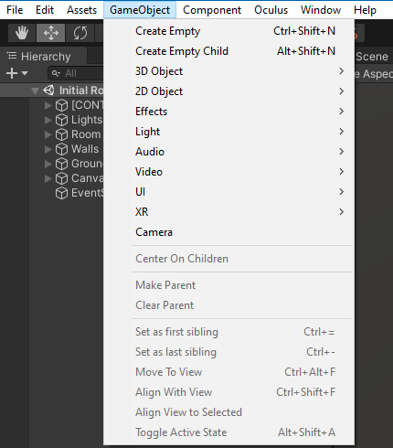

This is an image of the Unity3D menu where users can see the items provided by the Unity3D editor.

These tools can be used and built upon to create items for the users specific project and idea. For 3D objects, basic items such as cubes, spheres, cylinders, planes, and others can be used to create new items. In addition, Unity3D allows users to import their own 3D objects that they have created or choose already created assets from the Unity Asset Store. For this project, objects used were either created using Unity3D’s built in objects or obtained for free from the Unity Asset Store.

**The Oculus Quest and Hand Tracking Controls**

This section will describe the design details for the project, for more in depth descriptions on implementation details, please see the next chapter, Chapter IV. The Oculus Quest was chosen as the target Virtual Reality headset for the project because at the time, it was one of the most powerful all in one (meaning it requires no additional hardware, such as a PC) VR headsets available on the market. However, since the start of the project, the Oculus Quest 2 was released and is slightly more powerful. In addition, the Oculus Quest has built in hand tracking technology that allows users to control items in VR with only their hands. Users can simply put on the headset and not worry about holding anything else. They control everything with only their hands and gestures created by moving their hands and fingers. The combination of being a powerful all in one headset with hand tracking capabilities allow for ease of portability, ease of use, and less complication overall. In an educational environment, educators would not need to worry about any wires that get in the way or start any software on a separate computer, but rather they only need to have students put the headset on to start experiencing Virtual Reality.

The design process started with two test projects in Unity3D. The first of which was a simple application that was used to test out the headset and hand tracking. It was simple, the only things in the project were the users hands and a number of floating balls that the user can hit around. The second project was the recreation of a program previously created in Dr. Xiao’s HCI course. It was initially built to use Leap Motion hand tracking and output onto a standard computer monitor, but was now using Oculus Quest’s hand tracking and outputting on the headset. It is a simple game in which users push a ball up a slope into a hole. Both of these basic projects were simply proof of functionality for the Oculus Quest headset within a Unity3D project. Following these two basic projects, design for the actual project began.

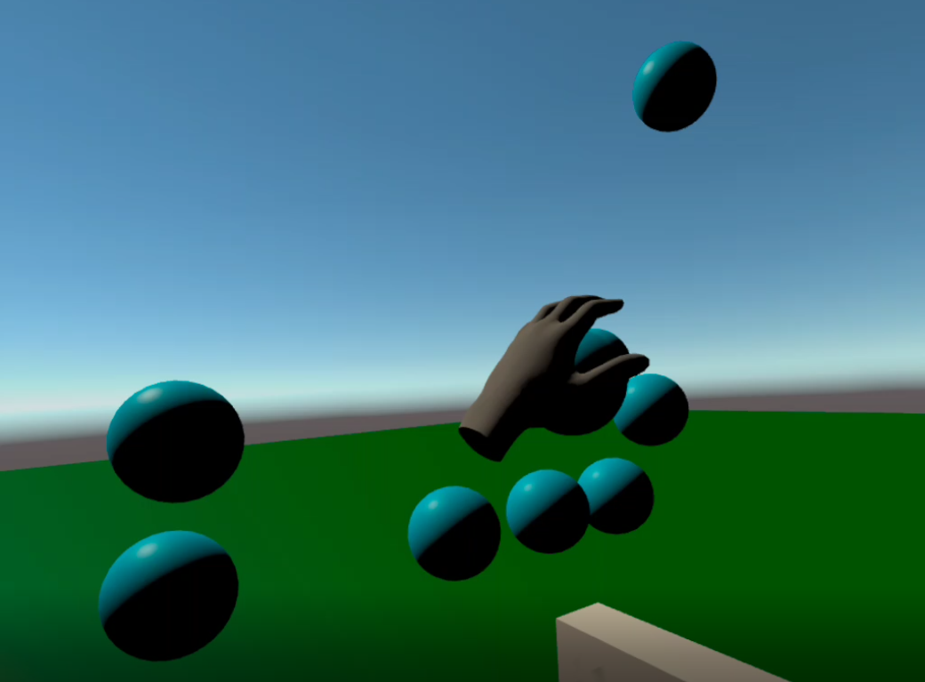

These images are from the two programs used to test the functionality of the Oculus Quest within Unity3D.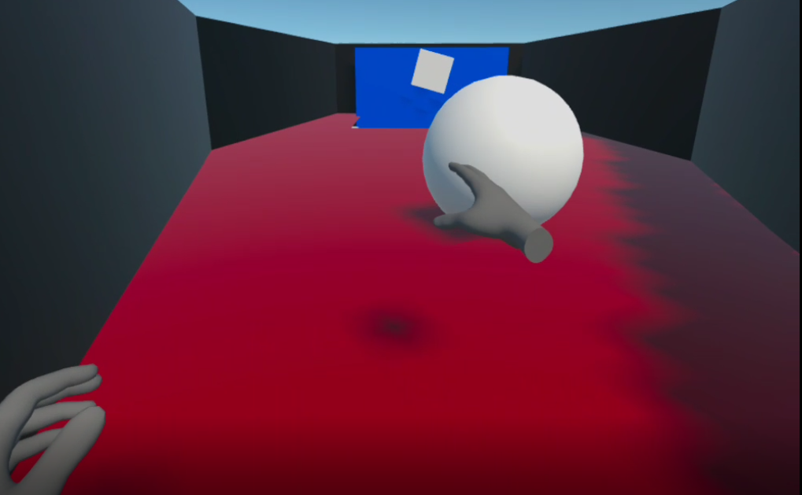

**The Initial Room**

When designing the initial room that the user of the application starts in, a sense of calm and cozy was desired. In order to achieve this, a small room that is similar to a study was created. For the structure of the room, Unity3D cube objects were used and converted into wall-like shapes. There were also a window and door inserted into the room to make it look more appealing and less like a dungeon. For the floor, a hardwood texture was used. A fireplace was also added, with it being one of the centerpieces of the space. The room was furnished with bookshelves filled with books, chairs, small paintings, shelving, a table, a clock, a globe, and a few other items. These items fill the room out more to make it look less bare. Each item in the room has physics built in to it, so if the user wants to interact with the item, they are able to.

These two images are of the three walls behind where the user will actually be looking most of the time. 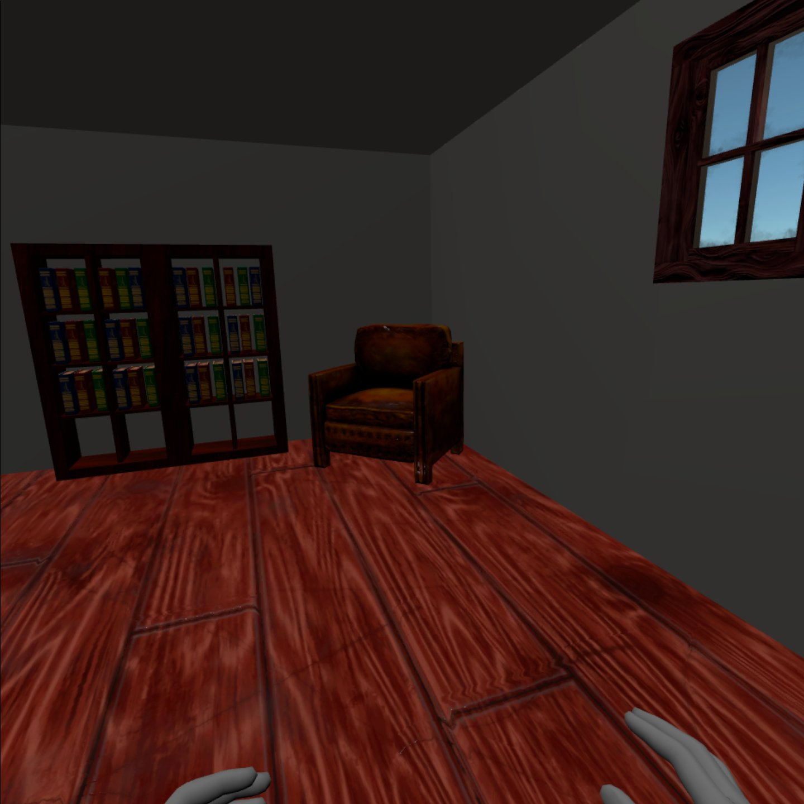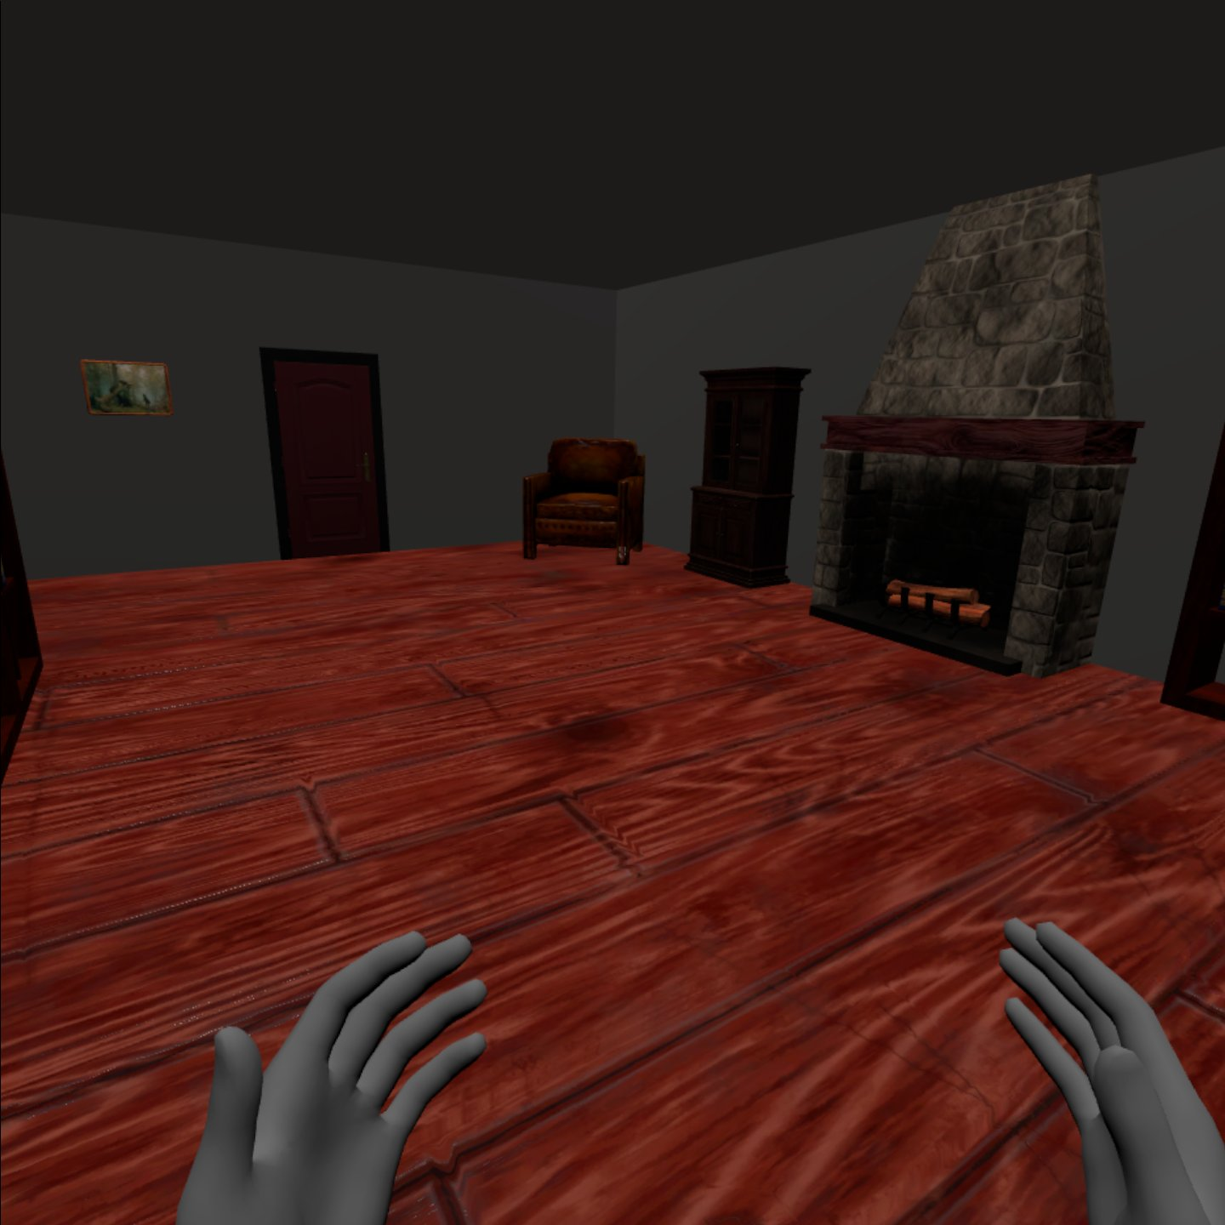

The main area in which the user will be interacting with the application is relatively small with the focus being on a table and the items on it. On the table are a few books. There are decorations surrounding the table to furnish the environment, but the books are the main focus. The books on the table are the ones that the user can pick up and read. The directions on how to do so, as well as the titles of the book, are present and in bright white lettering so that the user can clearly see them. These act as the main directions for the user and are simple to follow. The directions inform the user that way that they can pick up the book is by simply touching it. Initially, the user would have to physically lift the book, but this was not precise and difficult to do consistently. A more streamlined approach was necessary in order for the user to have a more enjoyable experience. This is what led to the current approach being used, meaning that the user only has to touch the book and it will open up for them.

The table and interaction directions in the initial room.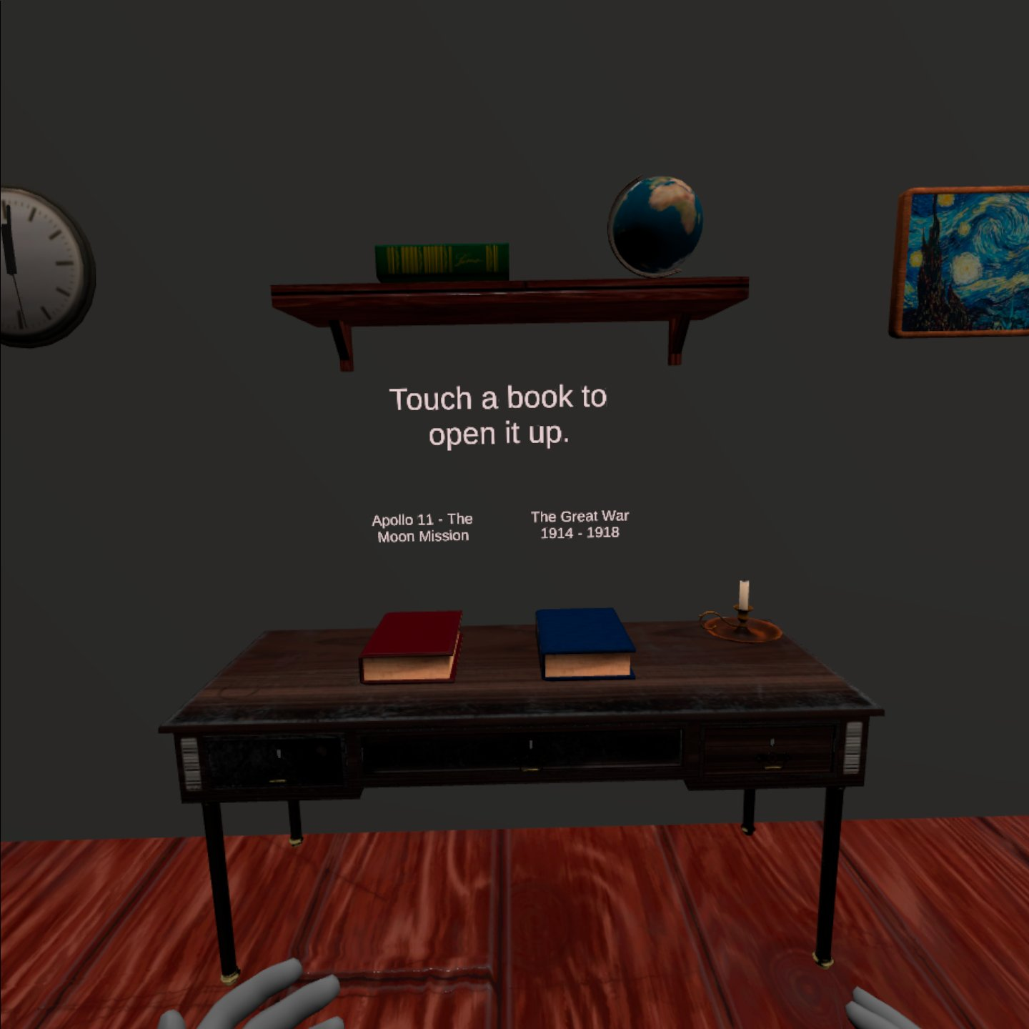

**The Reading Environment and Its UI**

Once the user touches the book, it will open up and attach itself to the center of the user's vision. Wherever the user looks, the book will follow. In addition to the open book, there are additional pieces of UI for the user. On each side of the book, an arrow is present that if pressed, changes the page. The arrows are labeled with directions to touch them to turn the page. In addition, there is a floating “book down” button that appears above the open book to the left that will close the book when the user touches it. It is clearly labeled. The final part of the book reading UI is the button that the user presses to transports the user to the environment that the reading material is about. In the case of the project so far, this environment is a battlefield from World War I. The button is located above the open book to the right and is also clearly labeled. Eventually, the button will only appear once the user reaches a certain page or chapter, but for now it is always present. All of these elements of the UI travel wherever the user goes within the virtual environment. Every item that the user needs to interact with the application is always present right in front of the user and at their fingertips.

The UI for the reading environment did not start this way and went through various changes. Initially, to put down the book, the user would have to touch the same book on the table that they previously touched to open it up. This was not as intuitive, as the open book covered up some of the user’s vision space, meaning that it was harder to find and see the book on the desk that they would have to touch to close the open book in front of them. In addition, this tied them down to a certain space in the virtual environment. With the new UI, the user is able to walk anywhere within the virtual environment to read and is able to close the book from anywhere as well. Additionally, the same issue was present for the button the user presses to transport to the environment that they are reading about. Initially, the button to transport to the environment that the user is reading about was placed on the table next to the book the user used to have to touch to close the open book. This had many of the same issues as the old close book functionality and was replaced for the button that is present in the UI that travels with the user.

Old UI with the “book down button” being on the table as well as the transport button being on the table as well.

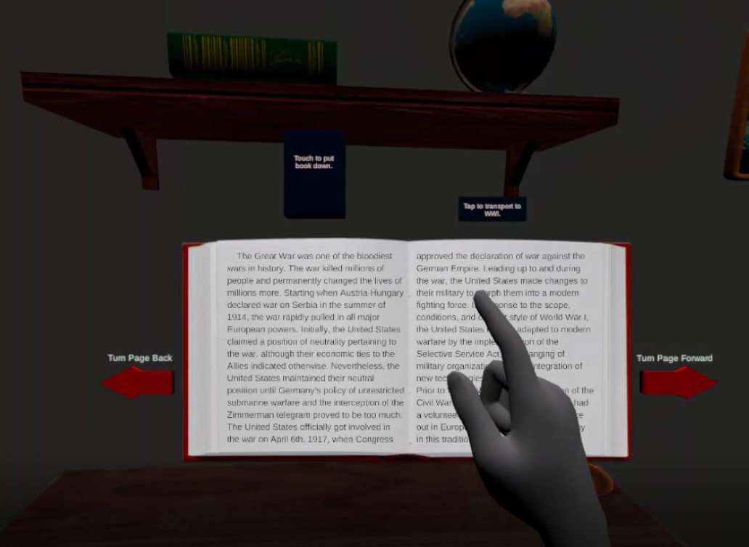

The new UI in which everything travels with the user’s vision.

The reasoning for the change in UI was testing. After much testing done by myself, I became annoyed at having to go back to the table to put the book down or travel to the reading material environment. The open book obscured vision and the location of the buttons anchored one to the table area within the virtual environment. Other users also tested out the old UI and agreed that it needed to change. After completing the new UI, myself and other users were more satisfied with the experience. In addition, the new UI is, unsurprisingly, faster to access for the users.

(After more testing over Christmas break, a summary of how much faster the new UI is than the old one will be placed here)

Overall, the current reading environment and its UI allows the user to read the book anywhere they want and perform any action necessary in an easy, simple way.

**The Reading Material Environments**

After the user presses the button to transport them to the environment that they are reading about, the environment will appear. In the case of the project so far, the environment that the user can transport to is a World War I battlefield. The purpose of being able to transport to the environment that the user is reading about is to see first hand the material that is being described in a book or story. This allows users to experience history or even fictional environments (if implemented) in an immersive manner that can aid in the learning experience. In creating the World War I battlefield, free assets from the Unity Asset store were used. The assets included a basic battlefield layout that was used as the base for the environment. Other items such as tree stumps were added with more and more things to be added in the future. Eventually, the environment will include items such as historical guns and potentially tanks, but at the moment they are not integrated. For the time being, the user can look around and explore the battlefield and trenches if they choose. A battlefield was chosen as the environment to transport to because the reading material details how World War I changed the United States military, and the battlefields were a large contributor to these changes. Being so, the ability to see the battlefields that sparked the changes seemed desirable.

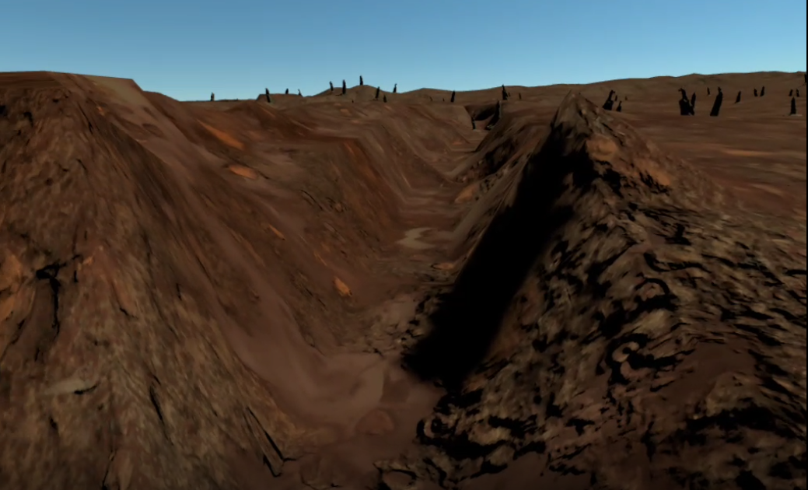

This is an image of the battlefield that users can transport to.

Overall, the project was designed to be an easy to follow experience in which the user is initially put into a comfortable environment where they can open up a book and read it in an intuitive manner and then can transport to an environment that correlates with the material that they are reading about when they reach a certain point in the book or story (At the current time, the ability to transport to the new environment is always present). The ways in which the user interacts with the UI went through changes sparked by much testing from myself and other users. In all, the experience is designed to allow users to read and experience history or fiction in an immersive, easy to understand manner.

**Chapter IV**

**Implementation**

When implementing the design choices for this project, previous Unity and C# knowledge was used in addition to documentation provided by Oculus and Unity. Before getting started on the actual project, the first step was to set up the Oculus Quest for development in Unity3D.

**Oculus Quest and Unity3D Setup**

To accomplish the setup, documentation provided by Oculus was used.[9] The following is a brief summary of the process followed using the documentation. For full instructions, visit the documentation links cited. The first step in the setup was to install the Unity3D editor on the PC where the development will be done. The version of Unity used for this project is 2019.4.9f1, which at the time was the most current stable version of Unity3D. After installing the Unity3D editor, the next step was to create a new project. Following this, enabling the Oculus Quest for development and testing was required. To do this, I had to install the Oculus App on my smartphone. Once installed, I had to connect the app to the Oculus Quest headset. On the app, a selection for “Developer mode” was then selected. Now, once the Oculus Quest is plugged into the PC in which Unity3D is installed, the headset will prompt the user to allow USB debugging.[10] From there, no further actions are needed from the headset itself.

Now, the rest of the work for setup was done through the Unity3D editor. The next important step was to import the Oculus Integration Package that is obtainable from the Unity Asset Store.[11] In order to do so, detailed instructions from Oculus were followed. The last and most convoluted step in the setup process was to configure a significant amount of settings. Detailed attention was paid to the documentation provided by Oculus.[12] Even with following the documentation, the process can be lengthy, but once completed, the development process for the Oculus Quest using Unity3D is straightforward and intuitive. The final result allows users to use an object in their Unity3D project called OVRCameraRig that acts as the main camera for the project and tracks the Oculus Quest headset in VR. Multiple settings are then configurable to fine tune the headset and camera if the user desires to do so. 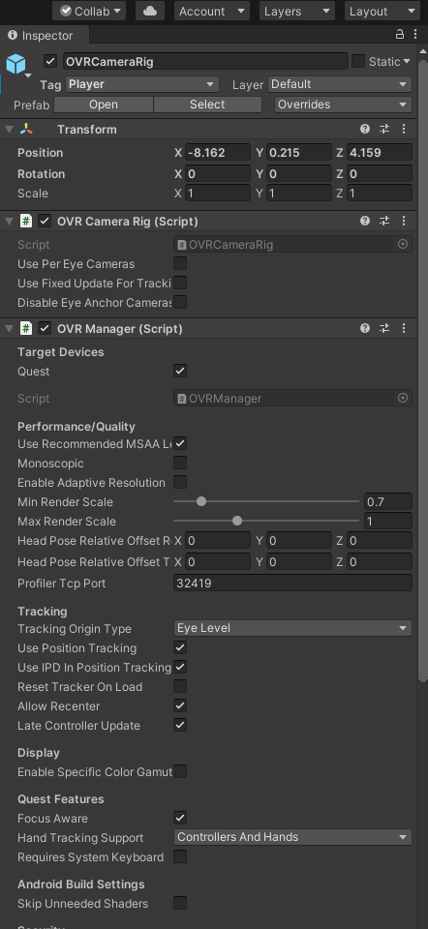

OVRCameraRig and its settings within Unity3D

**Hand Tracking Setup**

The next important step in the implementation process was to get hand tracking functional. Hand tracking is the user input method used for the project, instead of using standard controllers. Oculus also provided information on the hand tracking setup process. Detailed instructions were followed in order to get hand tracking functional.[13] In brief summary of the process, Oculus provides prefabs (3D objects) for the hands that are able to track the movement of each individual bone in the hand. Once these hand prefabs were added to the project, a number of other settings were required to be configured. This was pretty much the end of the documentation provided by Oculus. From there, a few things were still needed to get the hands functional within the project. The hand prefabs needed to have physics enabled, which was doable through some of the settings in Unity. This allowed the hands to actually interact with different 3D objects within the project. A few other settings were tuned and the end result was fully functional hand tracking in the Unity3D project.

**Testing and Running Unity3D Projects on Oculus Quest**

Before doing anything else, the developer must first have gone through the process to enable development for the Oculus Quest. This process and cited documentation is discussed above. The process allows users to create their own project applications.

After development was enabled and the Oculus Quest headset and hand tracking were set up within Unity3D, a way to test the functionality was needed. In order to push the project application to the Oculus Quest headset for testing, a few things needed configured within Unity3D. Most of the things were already done during the Oculus Quest setup process, but a few additional configurations were necessary. In Unity3D, a section called “Build Settings” is where the developer can configure how the application is built and run. Within this section, one must select the “Run Device” setting, which indicates the device that the project application will run on. The Oculus Quest must be selected for this. Additionally, this section lays out the different scenes, or environments created within the project. If there are multiple scenes or environments, the developer must select which ones to include in the build. If a scene is not selected, it is not put into the build and therefore the user cannot see it within the running project application. Next, the developer must connect the Oculus Quest headset to the computer that Unity3D is running on via USB-C cable. Once connected, the developer can click an option to “Build and Run” the project application. This will build the application, creating an apk file, and then push it onto the Oculus Quest headset. As a side note, the Oculus Quest is built off of an android system, which is why an apk file is created for the project application. The project application is then located on the Oculus Quest headset and can be run just like any other application by the user of the headset.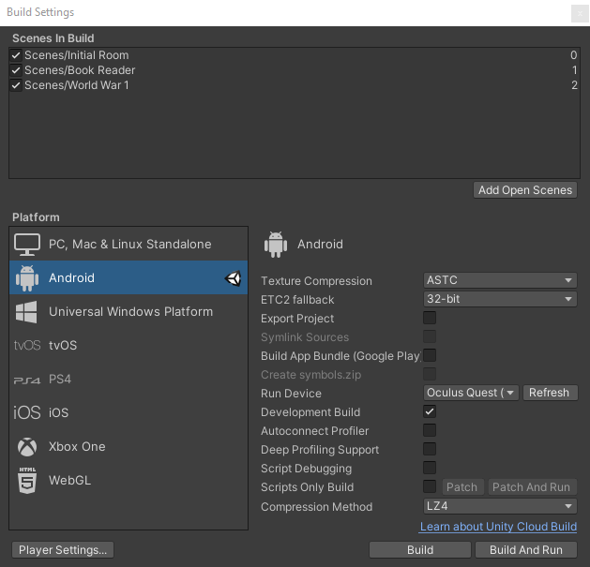

An example of the build settings for an Oculus Quest project with three scenes.

**Creation of the Rooms and Environments**

Therooms and environments that users can experience were created using the Unity3D editor. Within the editor, built in Unity3D objects as well as free assets from the Unity Asset Store were used. When implementing the design plan for the rooms and environments, Unity3D allows for precise positioning of objects so that the developer can place things exactly where they want. For detailed descriptions of the design of the environments and reasonings for doing so, please see Chapter III. Once all of the 3D objects that make up the rooms or environments were placed using the Unity3D editor, additional configuration had to be done to enable the objects to react to physics. Physics is an important part of the project. Without physics, items are static and allow no interaction from other objects. To implement physics, each item needed to have certain Unity3D attached to it. The items that need to be attached to it are called “Rigid Body” and “Box Collider” (or mesh collider). These items allow the object to detect other objects and react accordingly. For certain objects, colliders appear around the entire object and need no adjustment, but for others a great deal of adjustment is needed in order for the object to sense other objects that come in contact with it. This is solved via the Unity3D editor and also through testing. Physics, such as gravity, can be adjusted accordingly, but for this project are generally left at their default settings. In addition, lighting is an important part of the project.

Lighting the rooms and environments appropriately make a big difference in what is visible and how things look. Lighting and its effects are accomplished through the Unity3D editor. Unity allows for vast customization for lighting, but for the sake of this project, light is kept generally uniform so no shadows block out any of the environment objects. However, shadows may be implemented in the World War I battlefield in the future.

Overall, the implementation of the rooms and environments and the items in them was accomplished using the Unity3D editor.

This is an image of the Unity3D editor.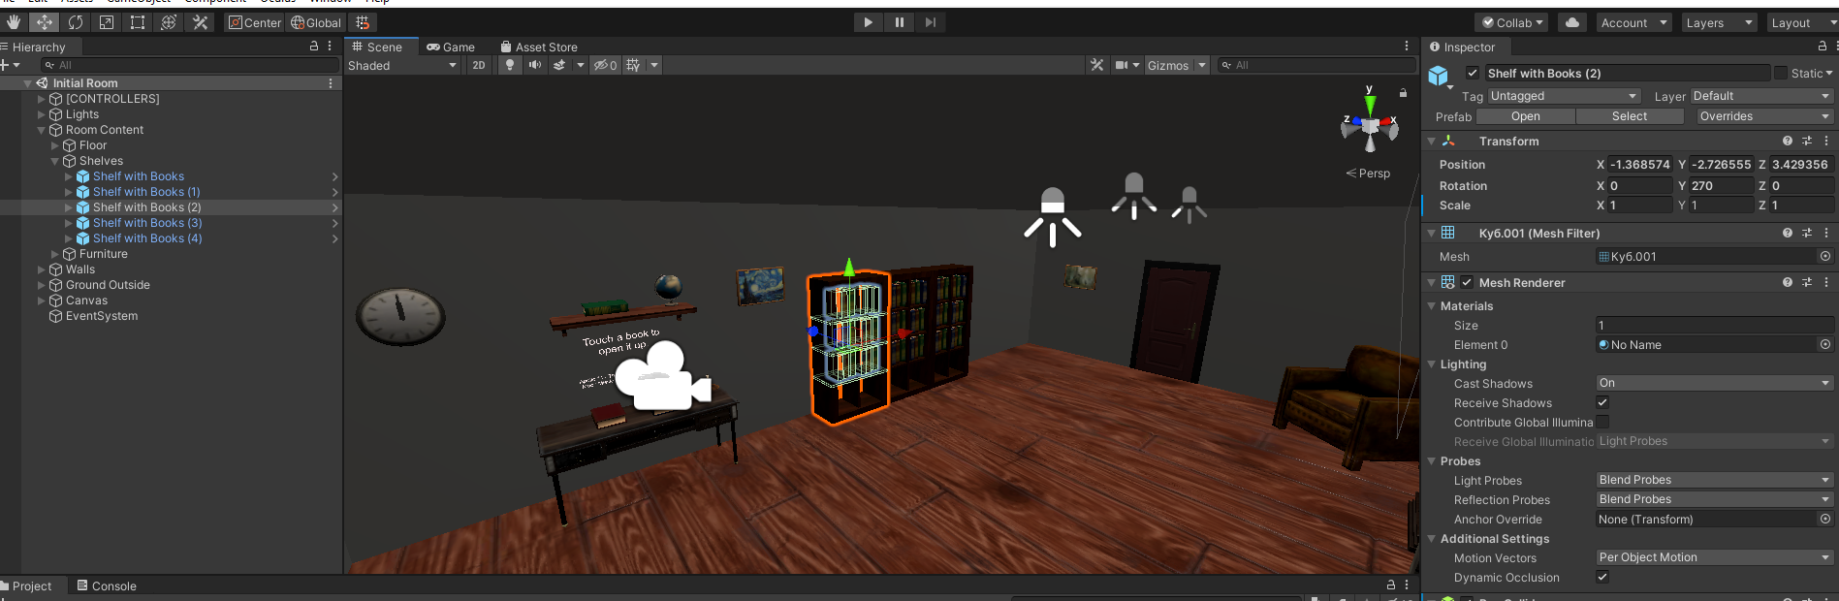

**Implementation of Opening The Book**

In the initial room that the user starts in when first starting up the project application, they appear in front of a desk. On the desk, a couple of books are set out along with labels on what they are about and how to open them. After much consideration, as discussed in Chapter III, the way to open up the books is to simply touch them. The way this was implemented took some time and consideration. Initially, I attempted to see if there was a way to detect the collision between the hand prefabs provided by Oculus and the book object set up on the table. After much trial and testing, this did not work reliably. An alternative approach was needed.

Instead of detecting the collision between the hands and the book, I decided to detect a collision between the book on the desk and an invisible set of planes that were set up around the book. These invisible planes set up around the book are floating, but can still be moved when things contact them. When the user goes to touch the book, they impact the invisible plane which in turn impacts the book. This concept is similar to that of a button. To detect the collision, a C# script is attached to the book that constantly checks to see if the collision is occurring, and if the script detects the collision, it opens up the book. To code this, the function called OnTriggerEnter() was used. This function is one used for Unity and documentation from Unity is provided for it.[14] Inside the function, I added code to do the actual detection and then open the book, which in reality is done by changing the scene to one in which the book is opened up. I also added a slight sleep function that will aid in preventing detecting the collision more than once. The code for the script can be seen below: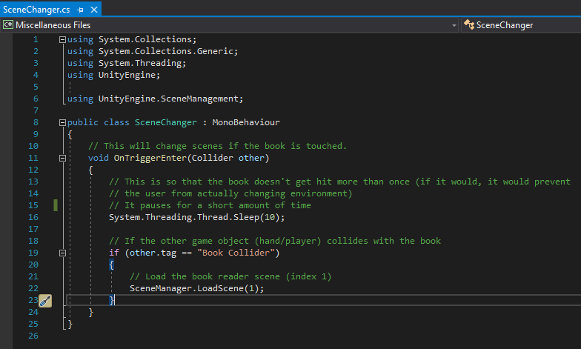

This is the SceneChanger script used to open the book.

**The Book Reader UI**

Once the user opens up the book, a new UI is present in front of them. The book is attached to the user’s vision and travels with them wherever they look. In addition, buttons to turn pages, a button to close the book, and a button to transport to the environment that they are reading about are also present and travel with the user’s vision. To implement this, a Unity “Canvas” was used. The canvas is an element provided by Unity that outputs UI elements. To get the canvas to follow wherever the user looks, some configuration was required. I needed to set the “Render Mode” to “Screen Space - Camera” and then set the “Render Camera” to the OVRCameraRig CenterEyeAnchor that represents the Oculus Quest headset. These settings can be seen below: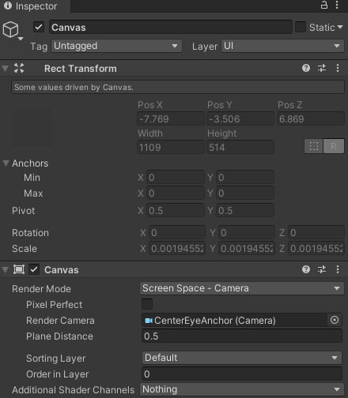

This image is of the settings for the Canvas UI object in Unity3D

After configuring the Canvas, I then had to add the objects that make up the book and other UI elements. For the book, a blank image of a book was used. For the pages within the book, a group of Unity UI Text objects were created and loaded with the page text. Only two images were made visible at once. Setting the visibility of the text objects was done through a C# script. For the button that puts the book down, a similar solution to that of how the user picks up the book was used. In front of the button is an invisible plane and when the user goes to touch the button, the plane contacts the button which in turn runs the script that puts the book down. The same idea was also used for the button that transports the user to the environment that they are reading about.

For the buttons that turn the pages, the detection for a button press remains the same as the other buttons, but in order to actually turn the page, another script was needed. The script that detects the forward or backward button press communicates with another script that is stored within the book object. The script stored within the book object controls the visibility of each page. The script contains a list of Unity GameObjects, which in this case are the text objects that store the words for the book. Because the script for the visibility of the pages is stored in the book object, the list storing the books appears within the Unity3D editor. This makes adding or removing pages simple. In Unity3D, to store new pages in the list found in the C# script, the developer needs only to drag the text objects into the list that appears in the Unity3D editor. This can be seen in the image below:

At the bottom of this image is the list of pages created in the C# script attached to the book object. 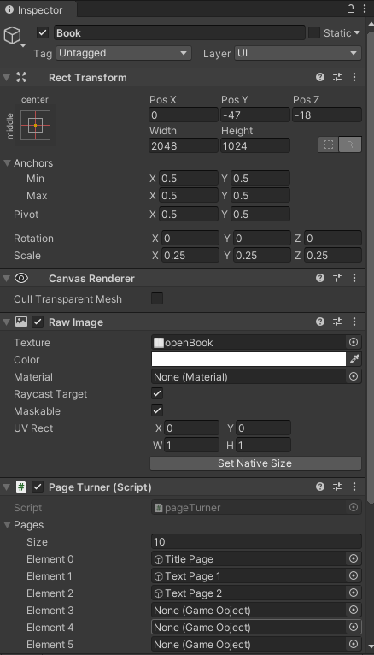

(The code for “turning the pages” or setting the visibility of each page using the page turn buttons is currently being worked on and will be completed soon)

This is the portion of the script that is stored in the book. This part of the script sets the first two pages of the book as visible and the rest as invisible at the start of the application.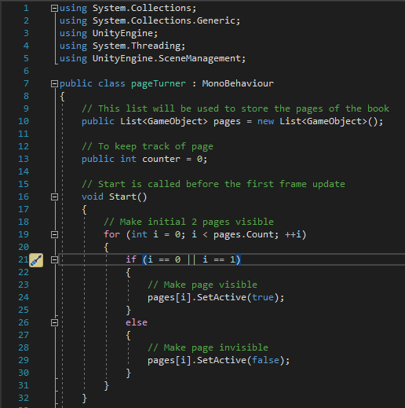

1. <https://www.oculus.com/go/?locale=en_US>
2. <https://www.oculus.com/quest/>
3. <https://www.oculus.com/quest-2/?locale=en_US>
4. <https://business.oculus.com/?locale=en_US>
5. <https://edu.google.com/products/vr-ar/expeditions/#about>
6. <https://unity.com/solutions/architecture-engineering-construction>
7. <https://unity.com/solutions/film-animation-cinematics>
8. <https://unity.com/solutions/automotive-transportation-manufacturing>
9. <https://developer.oculus.com/documentation/unity/unity-gs-overview/>
10. <https://developer.oculus.com/documentation/unity/unity-enable-device/>
11. <https://developer.oculus.com/documentation/unity/unity-import/>
12. <https://developer.oculus.com/documentation/unity/unity-conf-settings/>
13. <https://developer.oculus.com/documentation/unity/unity-handtracking/?locale=en_US>
14. <https://docs.unity3d.com/ScriptReference/Collider.OnTriggerEnter.html>